***FLOWCHART:***

• Flowchart A graphical representation of the logic for the problem solving.

• The purpose of the flowchart is making the logic of the program in a visual

representation.

• Flowcharts is a diagram made up of boxes, diamonds, and other shapes, connected

by arrows.

• Each shape represents a step-in process and arrows show the order in which they

occur.

|  |  |
| --- | --- |
|  | OVAL – TERMINALS |
|  | PARALLELOGRAM – INPUT, OUTPUT |
|  | RECTANGLE – PROCESS |
|  | DIAMOND – DECISION MAKING |
| 26 Simbol-Simbol Flowchart Beserta Fungsinya Lengkap – Blog Mamikos | ARROW – FLOW LINES |
|  | TO REPRESENT A FUNCTION |
|  | CIRCLE – CONNECTOR |

***TOOLS USED TO DRAW FLOWCHART:***

**1. Smart Draw –** A good tool to draw and understand but can’t save the file in system it

can be used for free up to 7 days after that we must pay to use it.

**2. Canva –** A user-friendly tool which allows the user to view in mobile using the

application and can be saved in any format. Without even subscription all the

features were available.

**3. App.Diagrams.net -** The diagrams can be saved and also at any destination you want

it to be. But the Output Wasn’t precise and not in single page the saved diagrams

open up to the website.

**4. Lucidchart -** The diagrams can be directly stored into the system and has all the

features and also easy to use. It is required to be paid after some uses .

**5. Visme –** The tool is used for flowchart animation and content creating and in

teaching, but more tools are available when you pay for them.

**6. Zenflowchart –** The diagrams can be directly stored into the system and has all the

features and also easy to use. But it restricts to use more than 20 shapes on using the

21st shape it must be paid.

**7. Visual Paradiagram –** Visual paradiagram is explicitly designed for flowchart

drawing, it is also paid one to use but in complex algorithm cases it is the best

**8. Creatly –** This tool is used to design Unified Modeling Language (UML) and

flowcharts.

**9. Google Draw –** All the features are available and they are directly stored in the

Google Drive. It should be logged in using Email. But the page size was limited also

typing the algorithm wasn’t comfortable.

**EXP NO:1A**

**DATE:21.11.2022**

**DRAW FLOWCHART AND WRITE ALGORITHM FOR THE FOLLOWING PROBLEM.**

**STUDENT GRADE ANALYSIS**

**AIM:**

To draw flowchart and write algorithm for the following problem.

**ALGORITHM:**

**STEP 1:** Start.

**STEP 2:** Get the Number of students (N)

**STEP 3:** Assign i = 0.

**STEP 4:** Check for the condition i < N.

**4.1:** If True, Get Name, Roll.no and Marks m1, m2, m3, m4, m5.

**4.2:** Calculate Total = m1 + m2 + m3 + m4 + m5 and Average = Total / 5

**4.3:** Display Name and Roll Number.

**4.4:** Check for condition avg >= 30 and avg < 50.

**4.4.1:** If True Display the message your grade is c" and increase i value by 1.

**4.5:** Check for condition avg > 50 and avg < 80

**4.5.1:** If True Display the message "You grade is B" and increase i value by 1.

**4.6:** Check for the condition avg > 80 and avg ≤ 100

**4.6.1:** If True Display the message. "Your grade is A" and increase i value by 1.

**4.7:** Check for the condition avg < 30

**4.7.1 :** If true display the messege “ypour grade is D”

**STEP 5:** If false goto step 9

**STEP 6:** Stop.

**FLOWCHART:** 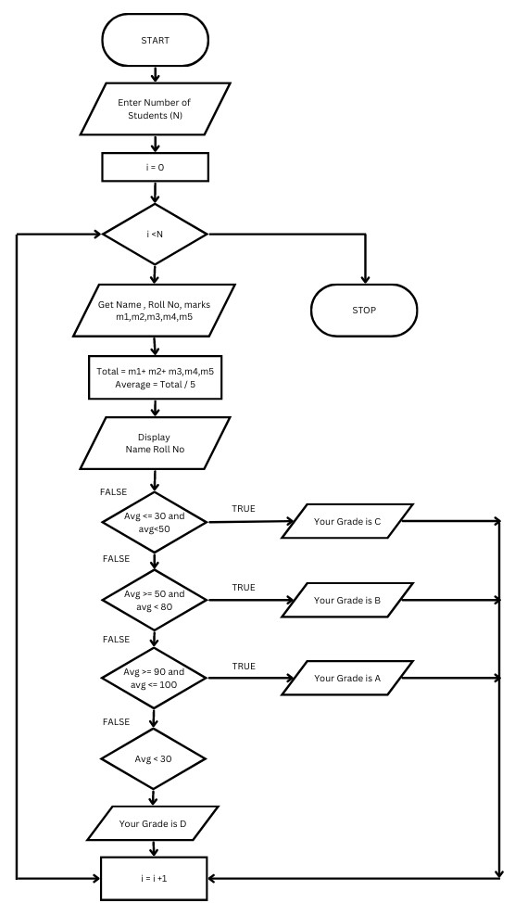

**PSEDOCODE:**

BEGIN

READ n

INITIALIZE i=0

IF i<=n

THEN READ Marks m1,m2,m3,m4,m5,name,roll no

CALCULATE Total=m1+m2+m3+m4+m5 AND Average =Total/5

DISPLAY name AND roll no

IF Average>=30 AND Average <=50

DISPLAY “ Your grade is C” AND INCREASE I value by 1

IF Average>=50 AND Average <80

DISPLAY “ Your grade is B” AND INCREASE I value by 1

IF Average>=30 AND Average <=50

DISPLAY “ Your grade is A” AND INCREASE I value by 1

IF Average<30

DISPLAY “ Your grade is D”

END

**RESULT :**Thus the algorithm and flowchart is given for the problem.

**EXP NO:1B**

**DATE:21.11.2022**

**DRAW FLOWCHART AND WRITE ALGORITHM FOR THE FOLLOWING PROBLEM.**

**ELECTRICITY BILLING**

**AIM:**

To draw flowchart and write algorithm for Electricity billing.

**ALGORITHM:**

**STEP 1:** Start.

**STEP 2:** Read values of last month, current

**STEP 3:** If current<=100 ,Display no of current charge otherwise go to step 4.

**STEP 4:** If current <=200, EC =(Unit -100)*1.5,FC=20,DC=80,display TC =EC+FC+DC else go to step 5.

**STEP 5:** If current <=500,EC =(100*2)+(unit -200 )*3.5 FC =30, DC=48, display TC=EC+FC+DC else go to step 6.

**STEP 6:** If current >500 ,EC =(100*3.5)+(300*4.5)+(unit-500)*6,FC=75,DC=100;display TC=EC+FC+DC

**STEP 7:**Stop.

**FLOWCHART:**

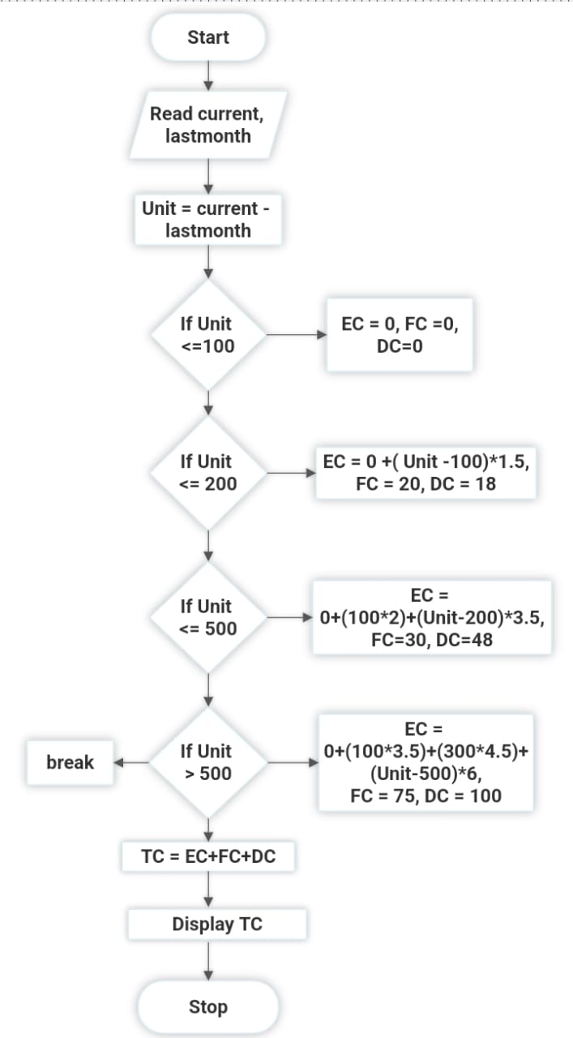

**PSEUDOCODE:**

BEGIN

READ current, lastmonth

SUBTRACT Unit = current – lastmonth

IF Unit<=100

EC = 0, FC =0, DC =0

IF Unit<=200

EC = 0+(Unit-100)*1.5, FC=20, DC=48

IF Unit<=500

EC = 0+(100*2)+(Unit-200)*3.5, FC = 30, DC = 48

IF Unit > 500

EC =0+(100*3.5)+(300*4.5)+(Unit-500)*6, FC = 75 ,DC=100

ADD TC = EC+FC+DC

DISPLAY TC

END

**RESULT:** Thus the algorithm and flowchart is given for the problem.

**EXP NO:1C**

**DATE:21.11.2022**

**DRAW FLOWCHART AND WRITE ALGORITHM FOR THE FOLLOWING PROBLEM.**

**CALCULATING THE WEIGHT OF THE STEEL ROD**

**AIM:**

To draw flowchart and write algorithm for the following problem.

**ALGORITHM**

**STEP 1:** Start

**STEP 2:** Get the no of rods as n

**STEP 3:** Initialize i=0 and total =0

**STEP 4:** Check i<n

**STEP 5:** If condition is true Get the diameter of the rod D

**5.1** Calculate the unit weight =D*2/162

**5.2** Get no of rods with diameter D

**5.3** Calculate weight of the rod = n *D+ unit weight

Add this weight to the total

**5.4**  Increment value i by 1

**STEP 6:** If condition is false ,display total as total weight of rod

**STEP 7:** Stop .

**FLOWCHART:**

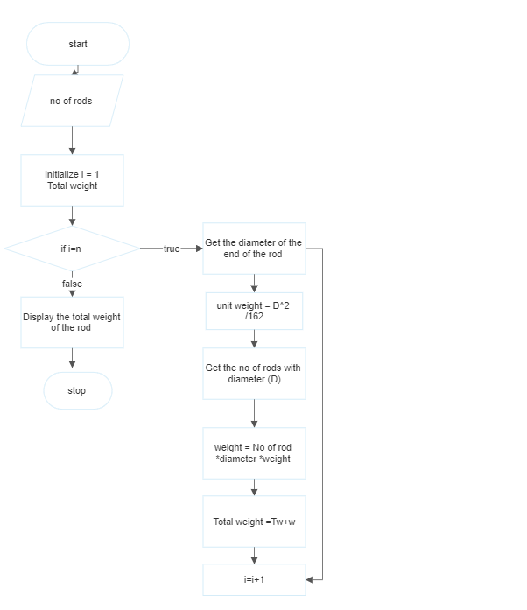

**PSEDOCODE:**

BEGIN

READ No of rods as n, d

INITIALIZE i =0

IF i <= n

THEN Unit weight = D^2/162

Weight= n*d*Unit Weight

Total = Total +Weight

i = i+1

DISPLAY Total Weight

END

**RESULT :** Thus the algorithm and flowchart is given for the problem.

**EXP NO:1D DATE :29.11.2022**

**DRAW FLOWCHART AND WRITE ALGORITHM FOR THE FOLLOWING PROBLEM.**

**SINE SERIES**

**AIM:**To draw flowchart and write algorithm for the following problem.

**ALGORITH STEP 1:** Start

**STEP 2:** Get the value of X

**STEP 3:** Initialize the value of i =1,sine =0 and import math.

**STEP 4 :** Get the value of i<=N

**STEP 5:** Check the values of i<= N

**5.1** If the condition is true ,convert X to radian and adding it to y.

**5.2** Let the value of s be (-1 ) to the power i

**5.3** Now calculate sine series

sine =sine +(y**2*i+1))/math.factorial (2*i+1)*s

**5.4** Increment value of i by 1

**STEP 6 :** If condition is false

Display sine

**STEP 7:** Stop .

**FLOWCHART:**

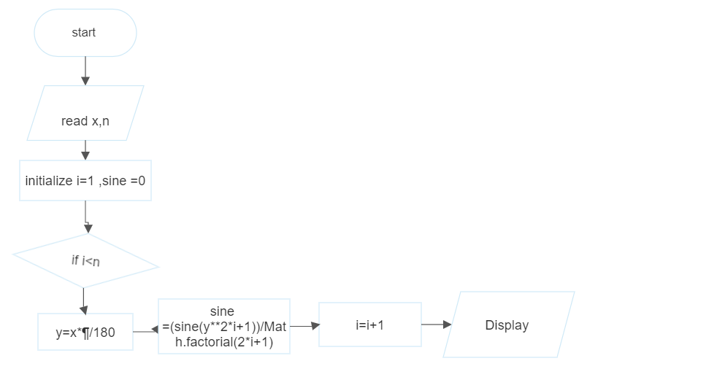

**RESULT :** Thus the algorithm and flowchart is given for the problem.

**EXP NO:1E**

**DATE:29.11.2022**

**DRAW FLOWCHART AND WRITE ALGORITHM FOR THE FOLLOWING PROBLEM**

**CALCULATE WEIGHT OF A MOTORBIKE**

**AIM:**

To draw flowchart and write algorithm for calculating weight of a motorbike.

**ALGORITHM:**

**STEP 1:** Start.

**STEP 2:** Get gross vehicle weight Rating GVWR

**STEP 3:** Get Dry weight (DW)

**STEP 4:** Get Fuel weight (FW)

**STEP 5:** Get Raider weight (RW)

**STEP 6:** Get Passenger weight (PW)

**STEP 7:** Calculate Total weight = DW+FW+RW+PW

**STEP 8:** Get Load.

**STEP 9:** Calculate safe weight. GVWR-Load-weight.

**STEP 10:** Check the condition safe weight >=0.

**10.1:** If true, print the message “You have a safe load and you can drive" goto stop.

**10.2:** If false, print the message "Reduce the load and then drive”.

**10.2.1:** GOTO step 8.

**STEP 11:** Stop.

**FLOWCHART:**

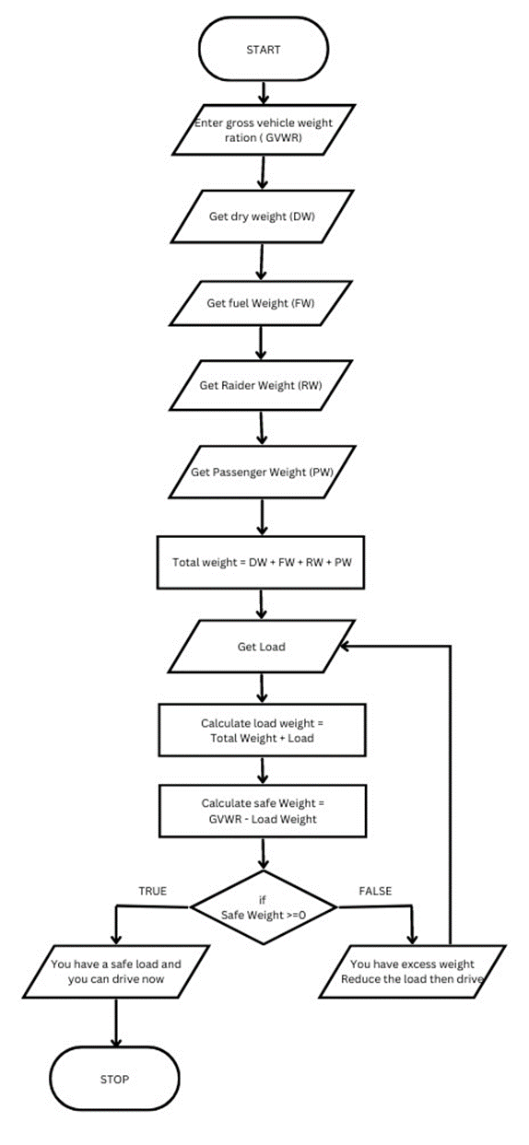

**PSEDOCODE:**

BEGIN

READ GVWR, DW, FW, RW, PW, Load

ADD Total Weight= GVWR+DW+FW+RW+PW

ADD Safe Weight = Load – Total Weight

IF Safe Weight >= 0

THEN DISPLAY “You have a safe load and you can drive”

ELSE

DISPLAY “Reduce the load and then drive”

END

**RESULT :** Thus the algorithm and flowchart is given for the problem.

**EXP NO:1F**

**DATE:29.11.2022**

**DRAW FLOWCHART AND WRITE ALGORITHM FOR THE FOLLOWING PROBLEM**

**RETAIL SHOP BILLING**

**AIM**:

To draw flowchart and write algorithm for calculating retail shop billing.

**ALGORITHM:**

**STEP 1:** Start

**STEP 2:** Get the value of bill no and bill date

**STEP 3:** Get details Name , address ,mobile no

**STEP 4:** Get no of items purchased as n

**STEP 5:** Initialize i = 0,total =0

**STEP 6:** Check condition i<=n **6.1:** If true, get name, Price,count and the discount.

**6.2:** Calculate the subtotal = count* Price – Discount/100

**6.3:** Add the value of subtotal to the total

**6.4:** Increment the value of i .

**6.5 :** If the condition is false

**6.6:** Get the value of GST

**6.6.1** Calculate total =total+ GST /100

**6.6.2** Display total

**STEP 7:** Stop

**FLOWCHART:**

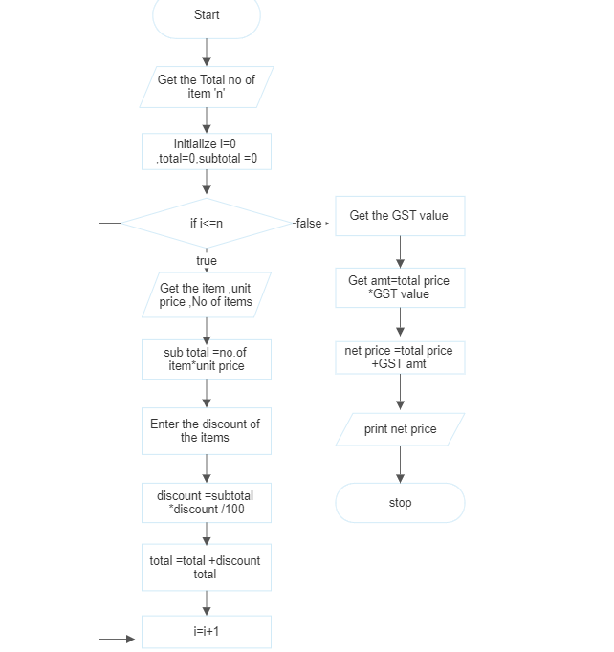

**PSEDOCODE:**

BEGIN

GET bill no ,bill date , Name, address , mobile no.

INITIALIZE i= 0, Total= 0, subtotal

IF i<=n

GET Name ,Price ,count and the Discount

THEN subtotal=count*Price-Discount/100

ADD the value of subtotal to the total

IF False

GET the value of GST

CALCULATE total=total +GST /100

DISPLAY total

i= i+1

END

**RESULT :** Thus the algorithm and flowchart is given for the problem.

**EXP NO:1F**

**DATE: 29.11.2022**

**DRAW FLOWCHART AND WRITE ALGORITHM FOR THE FOLLOWING PROBLEM****.**

**COMPUTING ELECTRICAL CURRENT IN 3 PHASE AC CIRCUIT**

**AIM**:

To draw flowchart and write algorithm for computing electrical current in 3 phase AC circuit

**ALGORITHM:**

**STEP 1:** Start

**STEP 2:** Read the values of pf, I, V

**STEP 3:** Calculate P using the formula **3.1:** P =√3* pf *I*V

**STEP 4:**Display “the result is P

**STEP 5:** Stop.

**FLOWCHART:**

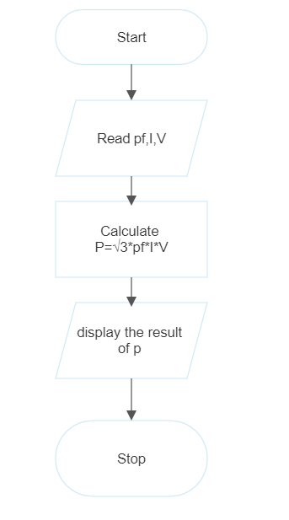

**PSEDOCODE:**

BEGIN

READ Pf, I, V

CALCULATE P ==√3 *Pf*I*V

DISPLAY P

END

**RESULT :** Thus the algorithm and flowchart is given for the problem.